How to Make a Category 5 / Cat 5E Patch Cable

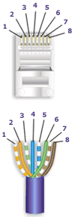
Pair # | Wire | Pin #
1-White/Blue | White/Blue | 5
1-White/Blue | Blue/White | 4
2-Wht./Orange | White/Orange | 1
2-Wht./Orange | Orange White | 2
3-White/Green | White/Green | 3
3-White/Green | Green/White | 6
4-White/Brown | White/Brown | 7
4-White/Brown | Brown/White | 8
568-B Diagram

568-B Wiring
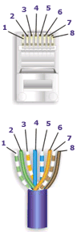
Pair # | Wire | Pin #
1-White/Blue | White/Blue | 5
1-White/Blue | Blue/White | 4
2-White/Green | White/Green | 1
2-White/Green | Green/White | 2
3-White/Orange | White/Orange | 3
3-White/Orange | Orange/White | 6
4-White/Brown | White/Brown | 7
4-White/Brown | Brown/White | 8
568-A Diagram

568-A Wiring

Notes for wiring diagrams above:

1. For patch cables, 568-B wiring is by far, the most common method.
2. There is no difference in connectivity between 568B and 568A cables. Either wiring should work fine on any system*. (*see notes below)
3. For a straight through cable, wire both ends identical.
4. For a crossover cable, wire one end 568A and the other end 568B.
5. Do not confuse pair numbers with pin numbers. A pair number is used for reference only (eg: 10BaseT Ethernet uses pairs 2 & 3). The pin numbers indicate actual physical locations on the plug and jack.

